**2110363 (Hardware Synthesis Laboratory I) of 1/2023**

6432158421 Vivatsathorn Thitasirivit

**VerilogPong**

An FPGA-based Pong game with some twists written in Verilog HDL. This game has two pongs (balls). The paddles can be moved in both X and Y direction. The game will end if either player has scored 21 or more. It also features a “dealbreaker” scoring which the player has to score 2 more balls than another player to win. The design is very modular and scalable, like in this example, I scaled paddles to move in both X and Y directions and summon two pongs.

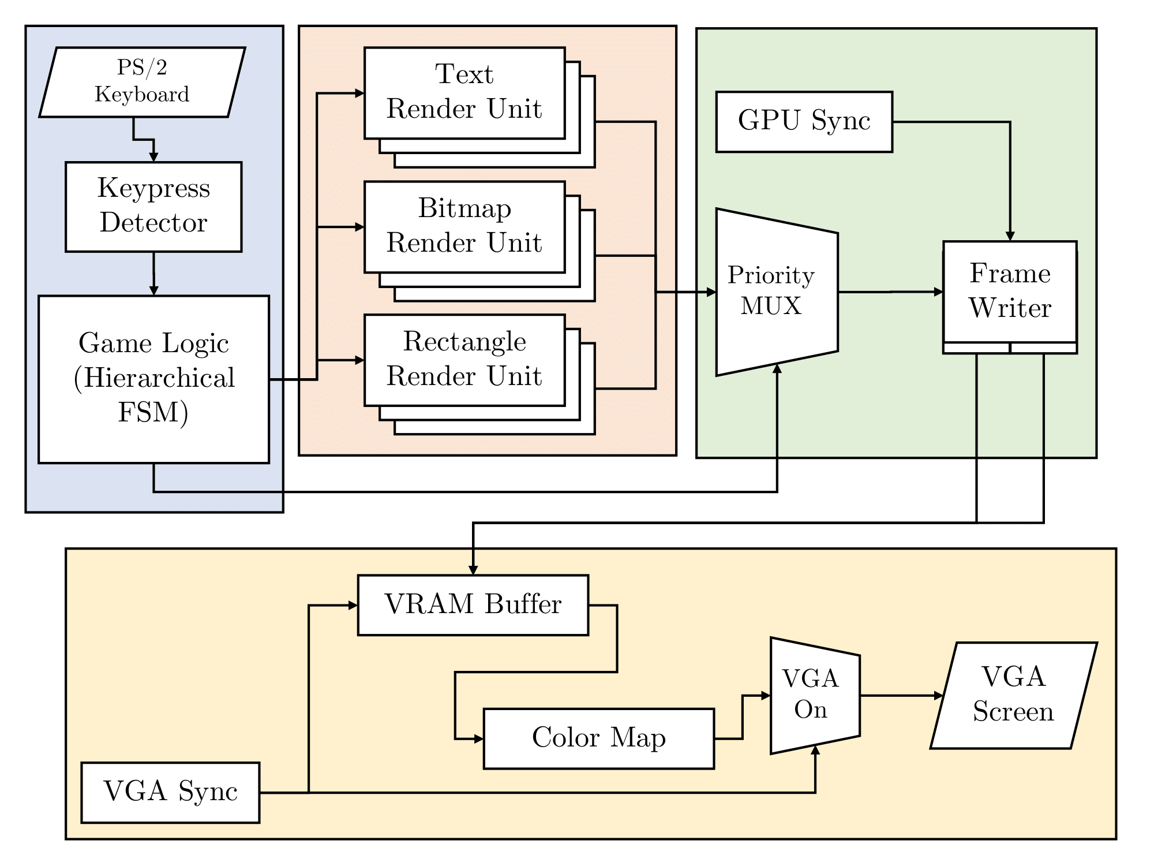

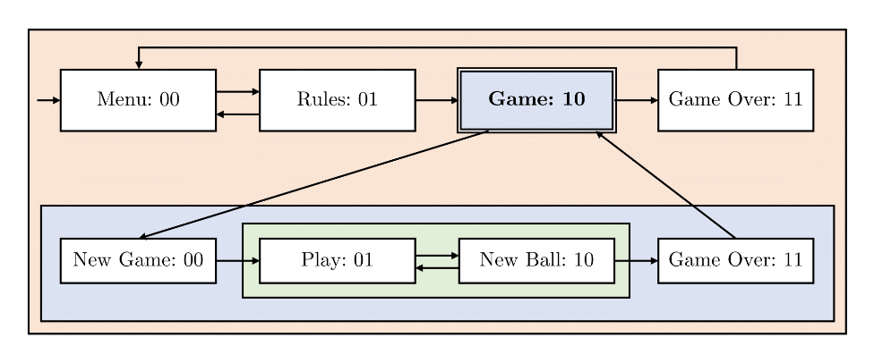

**Hierarchical Finite State Machine**

**PS/2 Keyboard Controller**

**Text Render Unit**

**Rectangle Render Unit**

**Bitmap Render Unit**

**Overall Architecture**